Admin Profile
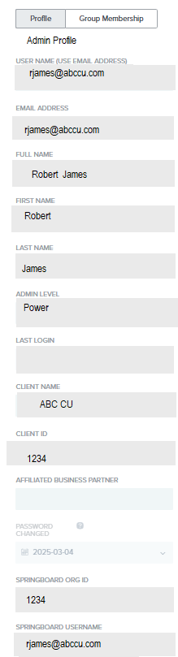

Teller Profile
Admin Level has to blank
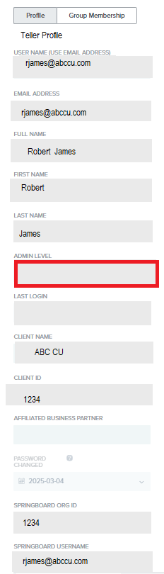

Admin Groups

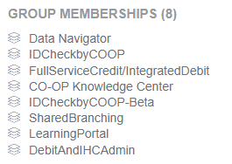
+ Delegated Admin

Teller groups

